Quick News on Measure E

March 2003

Here is an update on our Measure E projects. Below is a summary of the major projects and their status. The next 12-15 months will bring the peak of activity on the Measure E projects. Information on Measure E can be accessed on the De Anza web site. At the present time, there are 45 Measure E projects in design or construction on campus.

Just a reminder: All the Measure E projects are funded by the “Measure E” bond that was passed by voters in November 1999. This money is not general fund money and cannot be used to offset our current budget problems.

Projects Completed

√ Faculty Office Renovation Project
- Boilers
- Tree relocation
- Child Development Center (New addition)
- L 6 & 8 Quad Renovation
- A 5 & 7 Quad Renovation (Woodshop and Ceramics)
- E-2 (Engineering)
- OTI Relocation
- L 1, 4 & 5 Quad Renovation

Projects UNDER Construction

Child Development Center (renovation of old building – Wing A) The renovation of this building is progressing well and is nearly complete. The present completion date is March 25th.

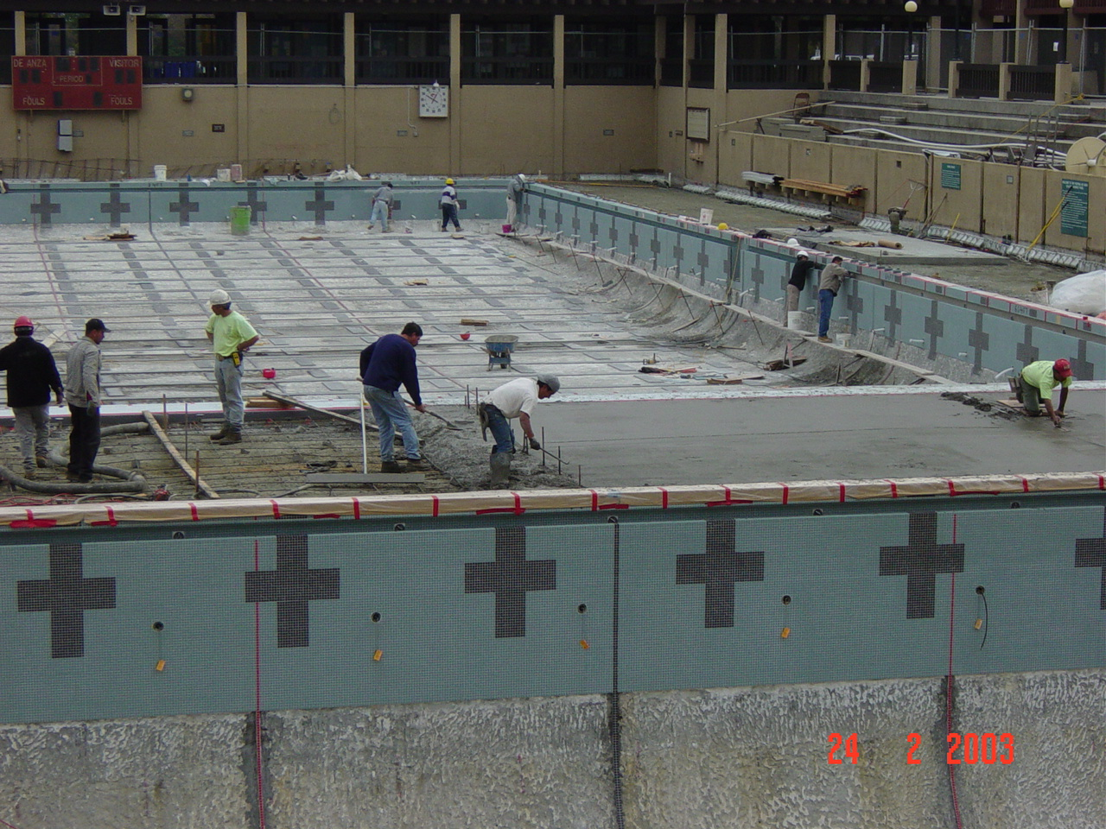
Pool Renovation: If you walk past the pool you will see that this project is close to completion. Presently the contractor is working on grouting, finishing the gutter, tile clean up, laying the concrete deck, and installing the fittings in competition pool. The pouring of the interior concrete and the filling of the pool should occur in early March. The projected date for completion of the pool is March 25th.

Child Development Center (renovation of old building – Wing B) This is the second part of the renovation of the old CDC building. We cleared this space in mid February, and the contractors began the renovations the week of February 17th. The renovation of this wing should be completed by mid May 2003, in time for the summer quarter.
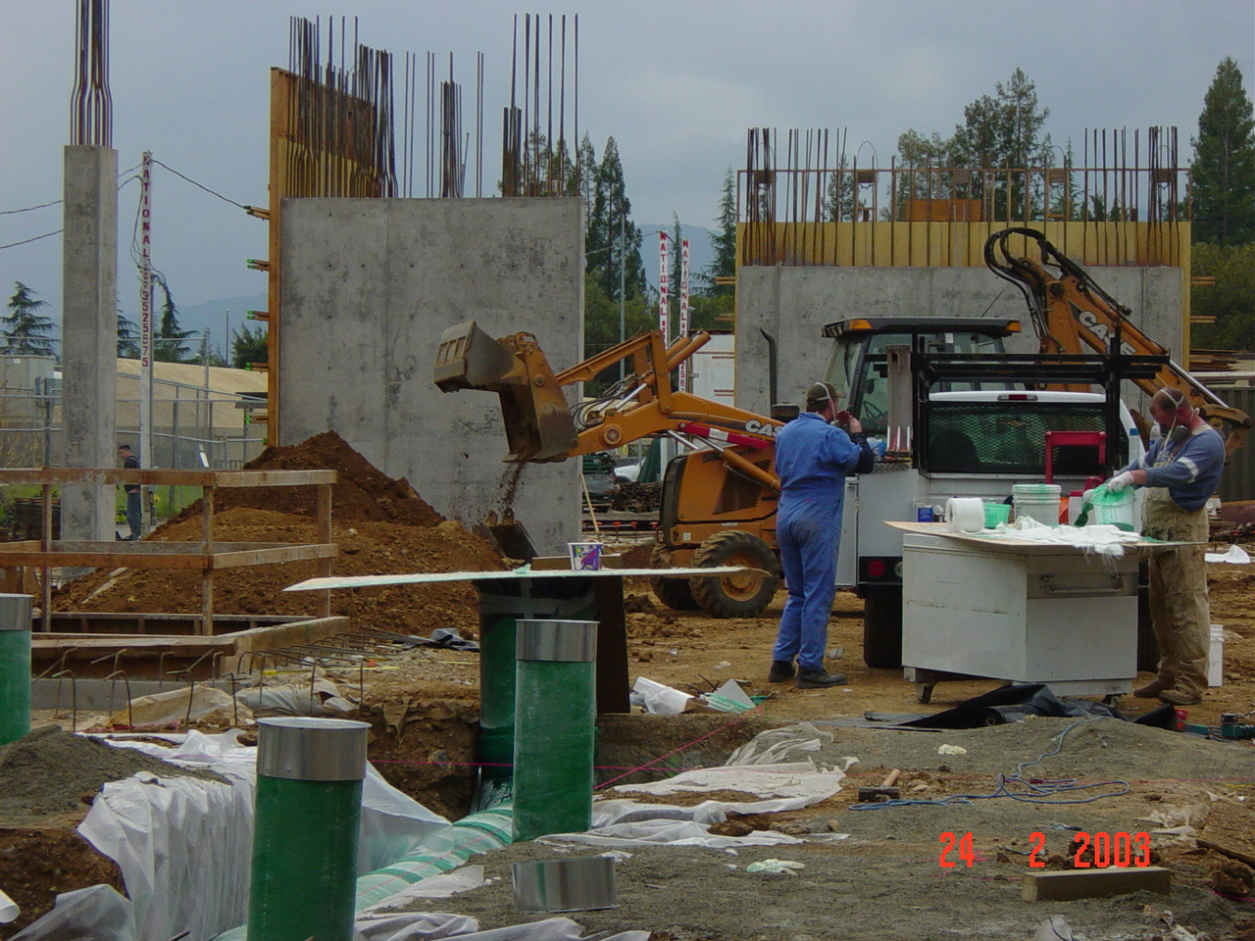

Science Center: The new science center building is really taking shape. The reinforcing steel is in place and concrete is being poured for the foundations for the building. The project is on schedule and on budget to be completed by April 2004. The building should be online by October 2004.

L 2, & 3 Renovation: Work is progressing on L 2 and should be complete by the end of April. Once L 2 is complete and the classrooms have moved back from the Mod Quad, renovations to L 3 will begin. Work on L 3 should run from April through July this year. L 3 classes will rotate out to the mod quad until renovations are complete.

Projects UNDER Design

Student & Community Services Center: This project is nearing the end of the construction document phase which is the final step in the design phase, The Department of the State Architect (DSA) is reviewing the project and should be complete by June this year which will allow us to award a bid in September this year. Construction is slated be begin in September 2003 and the building should be ready in spring 2005.

Parking Lot A & B Reconfiguration and Stelling Campus Entry: The College is reviewing the schematics and parking counts on this project to assure the parking goals are achieved. Once this is finalized, the project will go out to bid and work should start in April and be complete by July this year. With the reconfiguration of lots A & B and the building of the new parking structure in Lot C, the Stelling campus entry has to be redesigned. The project is currently in the construction documents phase and construction should begin in June and be complete by September this year. This entry reconfiguration is schedule to occur prior to the start of construction on the new parking deck in Lot C.

PE Quad and Athletic Fields: The PE Quad project is in the preliminary design development stage. Once finalized the construction documents will be drawn up and the project should be ready for bid in January through June 2004. Construction is scheduled for completion by February 2005. The Athletic fields project is nearing the end of the programming phase. Construction schedules are being analyzed to determine when construction could take place while minimizing the impact to the programs.

A Quad 1, 2, & 3 and 4, 6, 8 & 9 Renovation: The renovations to these buildings in the A quad will be done in rotation with the whole renovation project running from June 2003 – September 2004. The first buildings on the rotation will be A1, A2 & A3, which are scheduled to commence in June 2003 with completion in September 2003. Following on will be A4, A6, A8, &A9, which are scheduled for renovations in June – September 2004. This is a complex project to sequence due to programming considerations and the difficulty of providing swing space.

Kirsch Center for Environmental Studies: After much hard work from Julie Phillips and her 30 member team, the Kirsch Center design development drawings were approved by College Council and the Board. The final step in the design phase of the project is the construction drawings. Construction drawings should take approximately 4-5 months to complete. The project will be bid in Fall 2003 and should take 18-24 months to construct. The Kirsch Center is situated on the present site of the tennis courts.

Tennis Court Relocation: Presently we are in the construction documents phase (final part of the design & development phase). We will be bidding in April – June 2003 and the construction of the new courts over on the north side of the baseball field should run from June – September 2003. This project must be completed before Kirsch Center can start construction.

Planetarium: Presently we are in the programming phase. Thanks to the passage of prop 47, the college is scheduled to receive $1 million in state funding to cover about two-thirds of the cost of the star projector. We are writing grants for the balance of money needed for the projector. We are also applying for a large federal grant of $4m to $5m to house a state-of-the-art SGI projection system.

Warehouse/Bookstore Complex: We are currently in the design development stage of this project. Presently, construction is scheduled for May 2004 – February 2005.
S Quad Renovations: This project is in the beginning planning stages. We are looking at the programming and architectural selection at the present time.

Map: With so many projects underway, we realize it is difficult to keep track of them. Hopefully, this more visual summary of the campus projects will be a useful quick reference guide. The map on the website is in PowerPoint; you will need this program to open the file. A copy of the map is posted on the Measure E bulletin board in the administration building. If you would like a copy, please call Pippa at x8936.

The campus is now in an intensive period of construction activity and we realize that it adversely affects both staff and students. The great cooperation and commitment we have seen from everyone is very important. We rely on your support to help us mitigate the effects of the Measure E construction. We appreciate your patience, thank you.

